

Alli’s ABC’s on a healthy lifestyle



 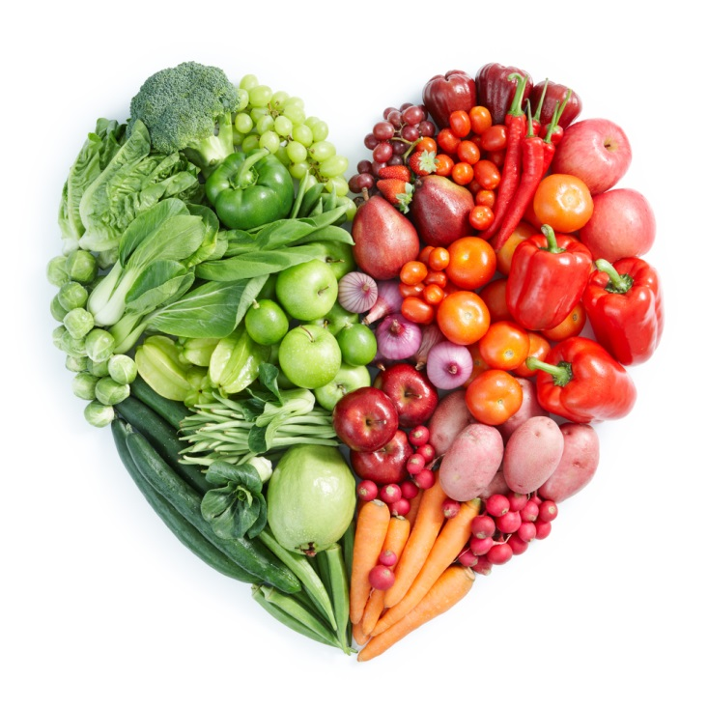

*Work Cited:*

Laurentiis, G. (2008, January 1). Food Network Recipes & Easy Cooking Techniques. Retrieved November 5, 2014, from <http://www.foodnetwork.com/recipes>

N.G. NutritionFacts.org | The Latest in Nutrition Related Research. (2010, February 1). Retrieved November 5, 2014, from <http://nutritionfacts.org>

N.G. The truth about fats: Bad and good. (2007, November 1). Retrieved November 5, 2014, from http://www.health.harvard.edu/fhg/updates/Truth-about-fats.shtml.

Roskelley, A. (2014, January 1). Dessert | Recipes | Super Healthy Kids. Retrieved November 5, 2014, from <http://www.superhealthykids.com/recipe-category/dessert>

*Work Cited:*

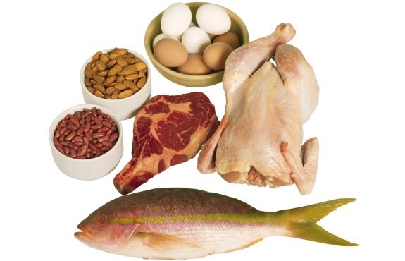

So should I feed my child protein all the time. 🡪

### Proteins are one of the best foods you can give your child because they help you in so many ways; here are a few:

* It can repair muscle tissue
* Also gain muscle tissue when consumed properly
* Strengths hair and nails
* Keeps your body strong and healthy, with no jetlag.

Fun facts!

Did you know that a normal regular sized steak is more than enough protein for your child’s daily dose? It is simple to ensure your child gets the protein they need to stay healthy?

If you are from the ages of 2-8 you would only need 4-5 ounces of protein a day.

For women you need to consume 6 ounces a day and for men it is 7 a day.

# Proteins

*Hello and welcome back to school! I hope everyone had a great summer vacation and you are refreshed and ready to start the year! I am Ms. Sherbel your child’s physical education teacher for the 2014-2015 school year. A little bit about myself: I went to Michigan State University, have a subject major in English and have a ZA endorsement in child development.*

*To start off this year right, I decided to send out weekly newsletter giving your children different ways on staying active outside of gym class and eating healthy in a world of junky temptation. This news article is for your child to use as a guide for being active and it would be great if you read it with them to get your child more motivated to participate.*

To start off this year right I decided to send out weekly newsletter giving your children different ways on staying active outside of gym class and eating healthy in a world of junky temptation. This news article is for your child to use as a guide for being active and it would be great if you read it with them to get your child more motivated to participate.

Actually no, even though proteins are very good for you, it is crucial that you still feed your child all of the basic food group’s every day, because each food in the different groups benefit your child in different ways.

If your child is between the ages of 2-6 you would only need 4-5 ounces of protein a day, for women it's 6 ounces and lastly for men it's 7 ounces a day.

# Healthy Proteins

# Beef/turkey jerky

# Mixed nuts

# Seeds

# Hard boiled eggs

# Fish

Welcome back to school!

Alli’s ABC’s on a healthy lifestyle

# Introduction

banner with apples and crayons

# Saturated Fats

# Allis ABC’s on a Healthy Lifestyle

There are some foods that can cause major distress to you and especially your child’s body. These foods contain saturated fats. Foods that you should not feed your child as often are the following:

* Pizza
* Butter
* Bacon
* Chocolate

**Basically any food that contains a lot of grease, which a child is drawn too.

# Healthy Saturated Fats

# 1. Coconut oil

# 2. Banana chips

# 3. Nutmeg

# 4. Nuts and seeds

# 5. Dark chocolate

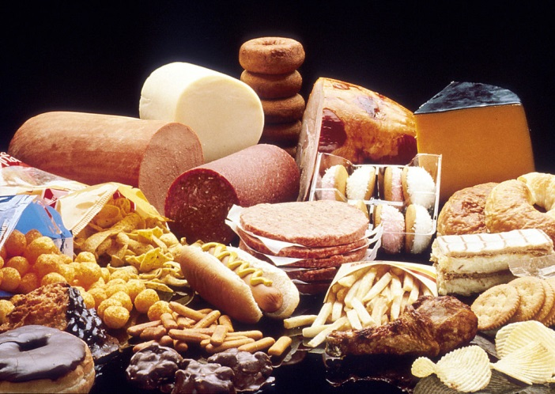



It is said by the leading medical authorities though out the world, including the World Health Organization, Dieticians of Canada, European food safety authority and many more that large amounts of fat can lead to serious illness later in life. These include:

* Different types of cancer (breast, ovarian, prostate, etc)
* Diabetes
* High cholesterol

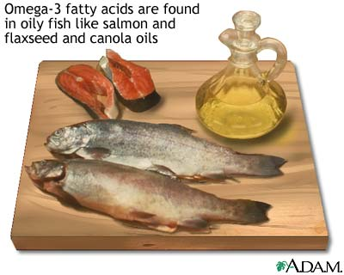

# 1. Olive oil

# 2. Peanut oil

# 3. Canola oil

# 4. Avocados

# 5. Most nuts

# Monounsaturated fats

# 1. Coffee

# 2. Salad

# 3. Soybean

# 4. Walnuts

# 5. Seeds

# Polyunsaturated fats

# Unsaturated fats

# Alli’s ABC’s on a Healthy Lifestyle

# There are two types of unsaturated fats:

# Polyunsaturated fats

# monounsaturated fats.

# Polyunsaturated fats are types of liquids that help build cell membranes and help prevent blood clotting.

# For example corn oil is a polyunsaturated fat. We use corn oil almost every day in cooking and in the foods we eat.

# Monounsaturated fats: These fats are the ones we should replace our saturated fats and trans fats in our diet. (They are better for you!)

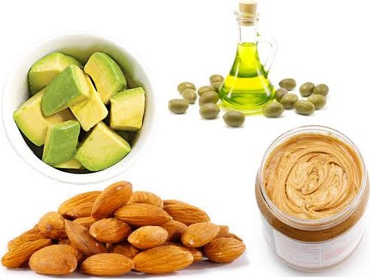

**FunFact:** monounsaturated fats help prevent and lower your cholesterol as you get older.

# Alli’s ABC’s on a Healthy Lifestyle

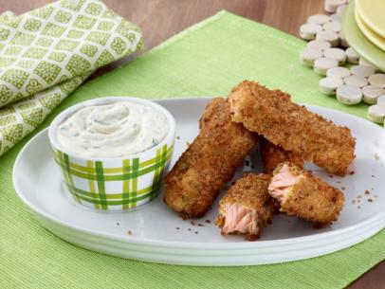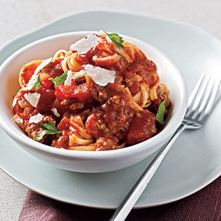

Now I know that was a lot to take in these past few weeks with all these big words and different foods that were good or bad for you, but I wanted to define these so you are aware of them if I put them in my newsletters.

Now, something I want to focus on is using these macronutrients that I discussed in past weeks are the ones that are good for you and your child. You should always be conscious of what you put in your child’s lunch for school, or their after school snack or the amount of desert they get after dinner. No idea what to serve them? Here are some recipes for healthy eating that you and your guardian could try and create that is under 350 calories!

Linguine

1 (18-ounce) center-cut salmon fillet, about 9 by 4 inches, skinned  
1/2 cup all-purpose flour  
1/2 teaspoon fine sea salt  
1/4 teaspoon freshly ground black pepper  
3 egg whites  
1 cup grated Parmesan  
1 cup seasoned bread crumbs  
Olive oil, for drizzling  
1/3 cup reduced fat mayonnaise  
1/3 cup lowfat plain yogurt  
1 tablespoon Dijon mustard  
1 tablespoon chopped fresh parsley or chives

# Parmesan fish sticks

1 (9-ounce) package fresh linguine

1/2 pound extra-lean ground beef

1/2 cup pre-chopped onion

1 tablespoon minced fresh garlic

1 teaspoon dried oregano

1/4 teaspoon salt

3 tablespoons tomato paste

1 (14.5-ounce) can diced tomatoes, undrained

1/4 cup (1 ounce) shaved Parmigiano-Reggiano cheese

1 tablespoon fresh flat-leaf parsley leaves

# carbohydrates

Instead of junky potato chips, you could find a healthy alternative that doesn’t contain as much fat like whole grain tortilla chips

**Healthy alternatives**

Instead of eating white bread with your sandwich, switch it up and have it with whole grain or wheat bread.

Even though fruits and vegetables don’t seem like carbohydrates they are one of the healthiest macronutrients you could eat.

Your child should be eating at least 15-20 grams of fiber a day, like a few weeks back when discussing protein; it doesn’t take a lot of food to consume your daily amount of macronutrients.

Carbohydrates are usually what I personally run for when I need a midnight snack. Carbs consist of any wheat product, rice, bread, soda, chips, cookies and many other snacks that we all know and love to munch on. Fortunately for us, it is easy to distinguish which carbohydrates are good for you and which ones aren't.

## 

1. potatoes
2. Legumes
3. milk
4. fruit
5. whole grain

## Healthy Carbohydrates:

Alli’s ABC’s on a healthy lifestyle